DATA STRUCTURE AND ALGORITHMS

Name- B. Sai Tripura
Class- CSE-A
Roll.no – AV.SC.U4CSE25018

INDEX:-
S. No | Experiment | Page No.
1 | 1(a) Recursive Rocket Launch Countdown  1(b) Recursive compound interest growth (power calculation)  1(c) Recursive Search for Employee ID in a List  1(d) Recursive Factorial Calculation  1(e) Recursive Fibonacci Series Generation | 6-7  8-9  10-11  12-13  14-15
2 | 2(a) linear search  2(b) binary search | 16-18  19-21
3 | 3(a) bubble sort  3(b) insertion sort  3(c) merge sort  3(d) selection sort  3(e) quick sort | 22-24  25-27  28-30  31-33  34-35
4(a) | Write a Python program to implement a Singly Linked List using a menu-driven approach. The program should:  - Create a singly linked list from an array of elements.  - Insert a node at the beginning.  - Insert a node at the end.  - Insert a node at a specific index.  - Delete a node from the beginning.  - Delete a node from the end.  - Delete a node containing a specific value.  - Count the number of nodes.  - Display the linked list.  - Exit the program. | 36-41
4(b) | Write a Python program to implement a Doubly Linked List using a menu-driven approach. The program should contain all the menu driven items listed in the above question  1.Create a singly linked list from an array of elements.  2.Insert a node at the beginning.  3.Insert a node at the end.  4.Insert a node at a specific index.  5.Delete a node from the beginning.  6.Delete a node from the end.  7.Delete a node containing a specific value.  8.Count the number of nodes.  9.Display the linked list.  10.Exit the program. | 42-50
4(c) | Write a Python program to implement a Circular Linked List using a menu-driven approach. The program should contain all the menu driven items listed in the above question  1.Create a singly linked list from an array of elements.  2.Insert a node at the beginning.  3.Insert a node at the end.  4.Insert a node at a specific index.  5.Delete a node from the beginning.  6.Delete a node from the end.  7.Delete a node containing a specific value.  8.Count the number of nodes.  9.Display the linked list.  10.Exit the program. | 51-59
5(a)  5(b) | Write a Python program to implement a Stack using Linked List with operations such as Push, Pop, Peek, and Display.  Write a Python program to implement a Stack using Array with operations such as Push, Pop, Peek, and Display. | 60-63  64-65
6(a)  6(b) | Write a Python program to implement a Queue using Linked List with operations such as Enqueue, Dequeue, and Display.(menu driven program)  Write a Python program to implement a Queue using Array with operations such as Enqueue, Dequeue, and Display. (menu driven program) | 66-79  70-71

LAB-1
1(a)
Recursive Rocket Launch Countdown
Aim:-
A rocket launch system displays a countdown before launching the rocket. Instead of using a loop, implement the countdown using recursion. Write a recursive Python program to display the countdown from n to 1, followed by "Launch!".
Code:-
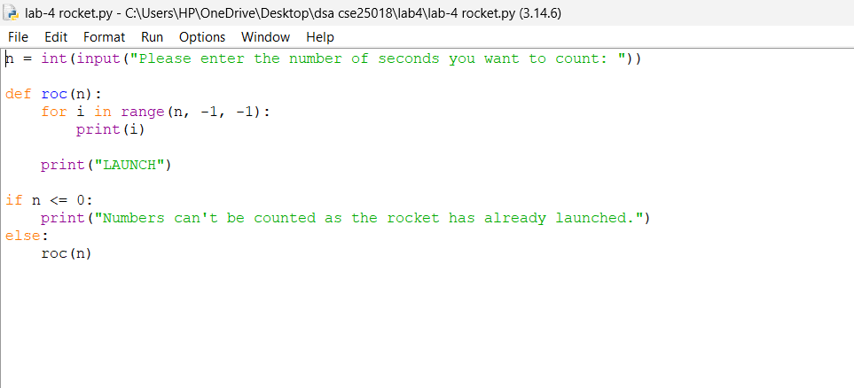
Output:-
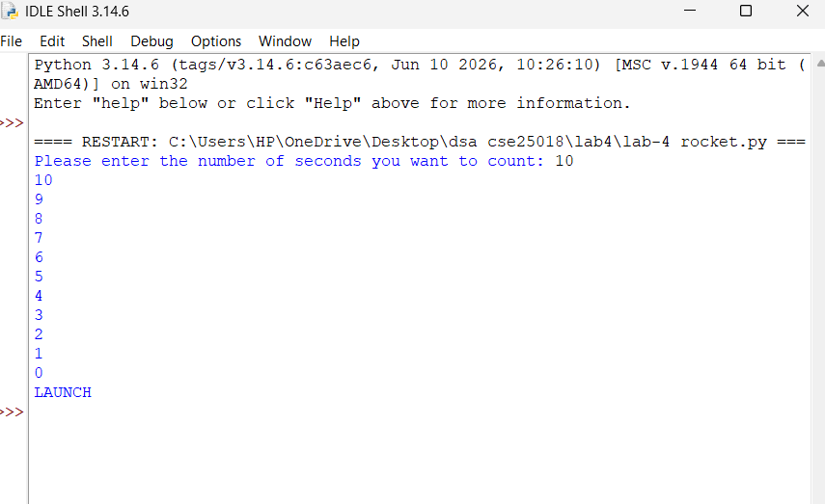

Explanation:-
The countdown function takes the current value of n as its parameter. On every call it first checks whether n has reached 0, which is the base case. When n is not 0, the function prints the current value of n and then calls itself again with the argument reduced by one, before the current call has finished. This pushes a new call on top of the previous one, so execution moves into the new call while the earlier one waits for it to complete. This repeats, with n decreasing by one each time, until the argument passed in becomes 0. At that point the base case is triggered, the message "Launch!" is printed, and the function returns without making another call. Because there is nothing left to execute after the recursive call in each earlier call, those calls simply return one after another once the base case finishes, without producing any further output. The countdown numbers therefore appear in decreasing order first, since each value is printed before the next call is made, and "Launch!" appears last, once the base case at the bottom of the recursion has been reached.

Error Table:-
S.No | Error / Exception | Cause and Correction
1 | Indentation error | Corrected it by giving required spaces
2 | ------------------ | ------------------
3 | ------------------ | ------------------

1(b)
Recursive Compound Interest Growth (Power Calculation)
Aim:-
Banks calculate the growth of an investment using compound interest. The formula requires calculating powers, which can be implemented recursively. Write a recursive Python program to calculate Pⁿ (power), where P is the principal growth factor and n is the number of years.
Code:-
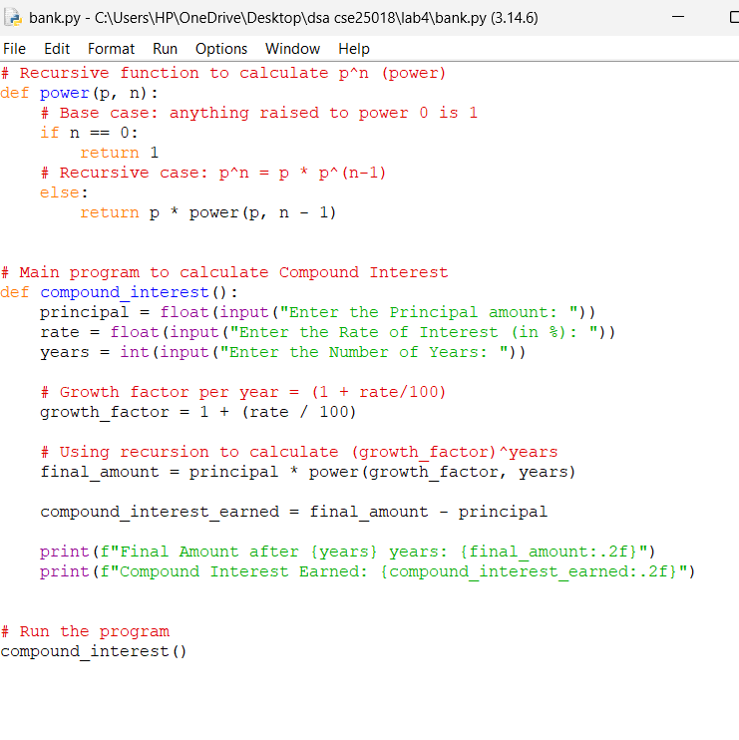
Output:-
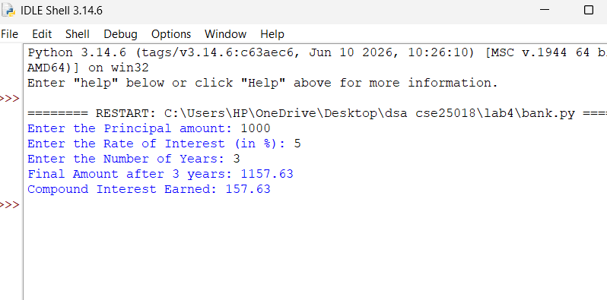
Explanation:-
The power function takes two parameters: P, the base, which stays the same across all calls, and n, the exponent, which decreases with each call. The base case checks whether n has become 0, and if so returns 1 directly, since any value raised to the power 0 is 1. Otherwise, the function returns P multiplied by the result of calling itself with the exponent reduced by one. Because this recursive call is part of a return statement, the current call cannot finish until the call it made returns a value, so each level of the recursion is left holding a pending multiplication by P until the base case is reached. Once the base case returns 1, that value is passed back to the call above it, which multiplies it by P and passes the result further up, and this continues until the outermost call returns. The final result is therefore built up only as the calls return, from the base case back to the original call, giving P multiplied by itself n times.

Error Table:-
S.No | Error / Exception | Cause and Correction
1 | No error | ---------------
Experiment - 1(c)
Recursive Search for Employee ID in a List
Aim:-
An HR department stores employee IDs in a list. Develop a recursive program to search for a given employee ID. Write a recursive function to search for an employee ID in a list.
Code:-
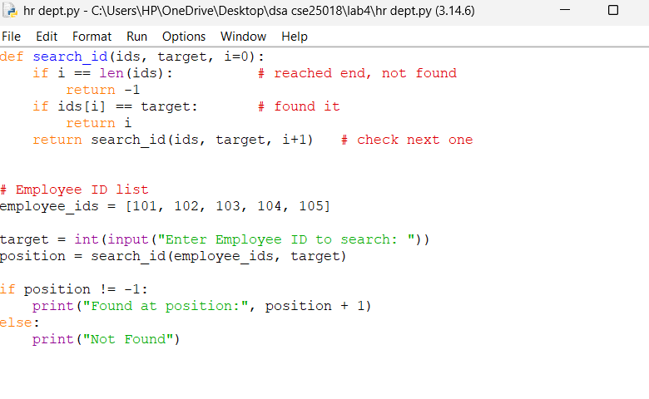
Output:-
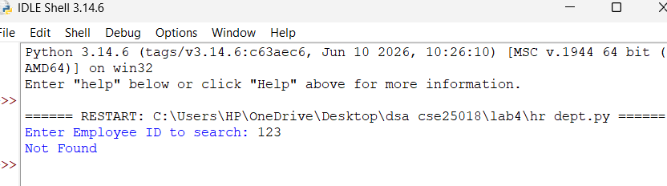
Explanation:-
The search function takes the list, the target employee ID to search for, and an index that tracks the current position, usually starting at 0. There are two separate base cases. The first checks whether the index has reached the length of the list, which means every element has already been checked without a match, and the function returns False. The second checks whether the element at the current index equals the target ID, and if so returns True immediately. When neither condition is satisfied, the function calls itself again with the index increased by one, and returns whatever that call produces. Because the result of the deeper call is returned directly without being modified, the answer found at any depth of the recursion is passed straight back up through every call above it unchanged. The recursion therefore moves forward through the list one position at a time, stopping as soon as a match is found or the list is exhausted.

Error Table:-
S.No | Error / Exception | Cause and Correction
1 | Indentation error | Corrected it by checking the gaps
2 | ------------------- | ----------------------------------------
3 | -------------------- | ----------------------------------------

Experiment -1(d)-
Recursive Factorial Calculation
Aim:-
In a logistics company, the number of possible ways to arrange n different parcels is calculated using the factorial number formula (n!). Develop a recursive program to calculate the factorial of a given number.
Code:-
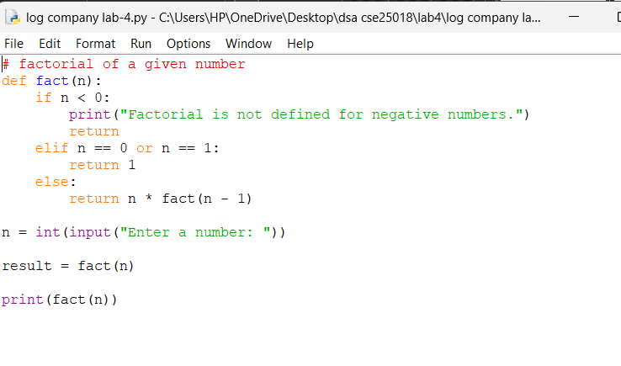
Output:-
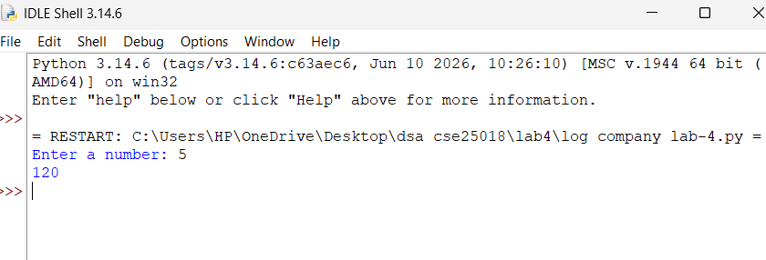

Explanation:-
The factorial function checks whether n is 0 or 1 as its base case, since factorial is defined to stop at 1, and returns 1 directly in either case without further calls. For any other value, the function returns n multiplied by the result of calling itself with the argument reduced by one. As this call is inside a return statement, each call remains active on the stack, waiting for the call it made to finish, until the base case is reached. Once the base case returns 1, that value is passed back up, and each waiting call multiplies it by its own value of n before passing the result further up the chain. This means the multiplications only happen while the calls are returning, working from the smallest value back up to the original input, and the final value produced at the top of the stack is the factorial of the original number.

Error Table:-
S.No | Error / Exception | Cause and Correction
1 | No error | ---------------
2 | No error | --------------

Experiment -1(e)
Recursive Fibonacci Series Generation
Aim:-
Write a recursive Python program to print the first n terms of the Fibonacci series.
Code:-
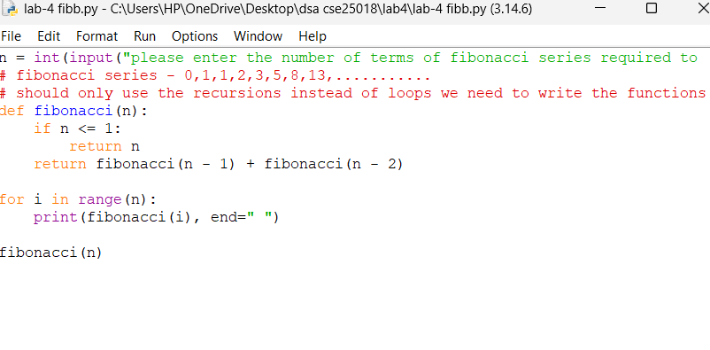

Output:-
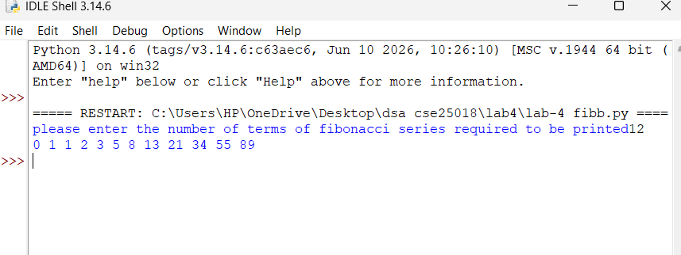

Explanation:-
The fibonacci function has two base cases: when n is 0 it returns 0, and when n is 1 it returns 1, since these are the two starting values of the series. For any other value of n, the function returns the sum of two recursive calls, one with n - 1 and one with n - 2, instead of making a single call as in the earlier examples. Each of these two calls again splits into two further calls unless it hits a base case, so the calls form a branching tree rather than a single chain. Every branch eventually reaches n == 0 or n == 1, returns the corresponding fixed value, and these returned values are added together and passed back up to whichever call made the two sub-calls. To print the first n terms, the function is called separately once for each position in the series, from 0 up to n - 1, and each returned value is printed in order, producing the familiar Fibonacci sequence.
Error Table:-
S.No | Error / Exception | Cause and Correction
1 | ------------------- | -------------------
2 | ------------------ | -------------------
3 | ------------------ | -----------------

Lab-2
Question 1: Linear Search
Question
Write a Python program to perform linear search on a list of elements entered by the user.
Aim:-
To implement and understand the working of the Linear Search algorithm, which searches for a target element by checking each element of the list sequentially from the beginning until the target is found or the list ends.

Code:-
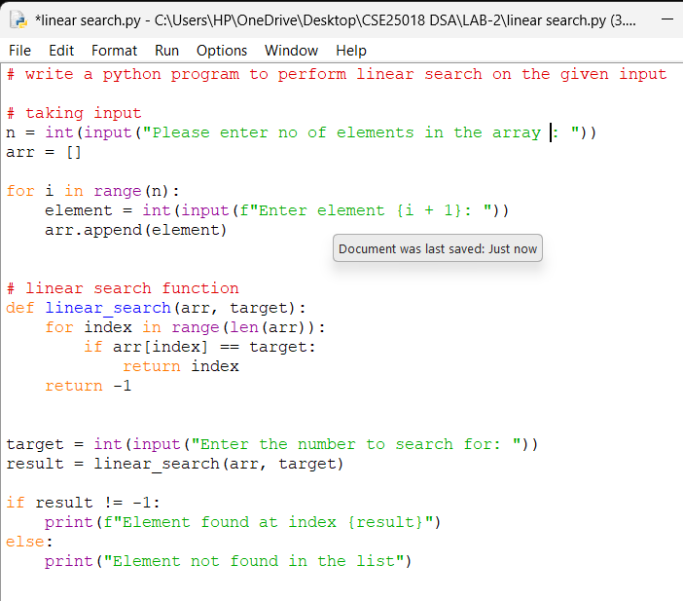
Output:-
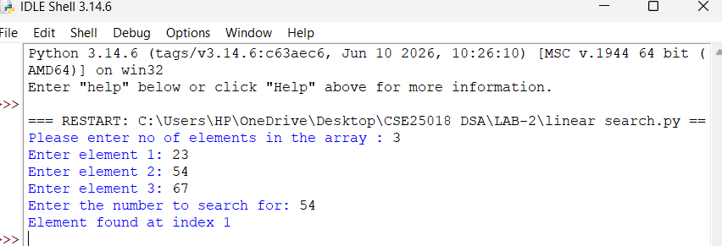
Explanation:-
The program first takes the number of elements and the elements themselves as input from the user and stores them in a list. The linear_search function then iterates through the list one element at a time, starting from index 0, and compares each element with the target value. If a match is found, the function immediately returns the index of that element. If the loop completes without finding a match, the function returns -1, indicating that the element is not present in the list. Linear search does not require the list to be sorted and works correctly on any arrangement of elements. Its time complexity is O(n) in the worst case, since every element may need to be checked once.

Error Table:-
S.No | Error / Exception | Cause | Solution
1 | ValueError | User enters a non-integer value when prompted for the number of elements or the array elements. | Enter only valid integer values when prompted, or add input validation using try-except.
2 | Element not found | The target value does not exist anywhere in the entered list. | This is expected behaviour; the function correctly returns -1 and the program prints 'Element not found'.
3 | Program appears to do nothing on large input | User enters a very large value of n, causing many repeated input prompts. | Enter a reasonable, intended value of n that matches the number of elements you plan to type.

Question 2: Binary Search
Question-
Write a Python program to perform binary search on a sorted list of elements entered by the user.
Aim:-
To implement and understand the working of the Binary Search algorithm, which efficiently locates a target element in a sorted list by repeatedly dividing the search interval in half.
Code:-
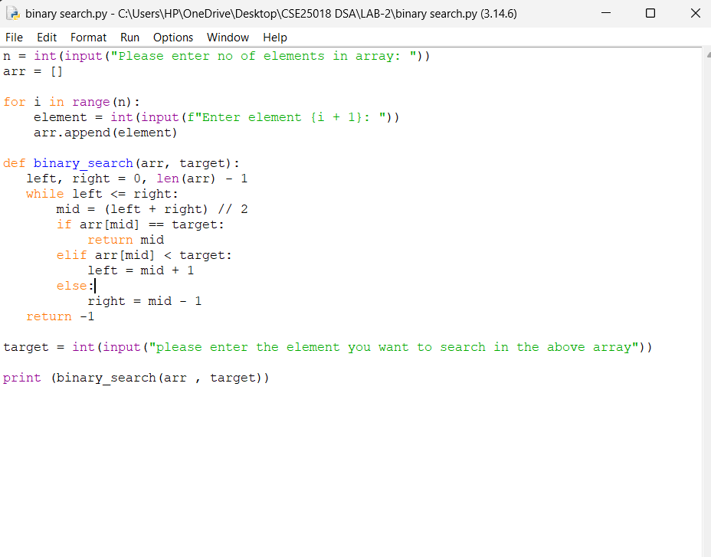

Output:-
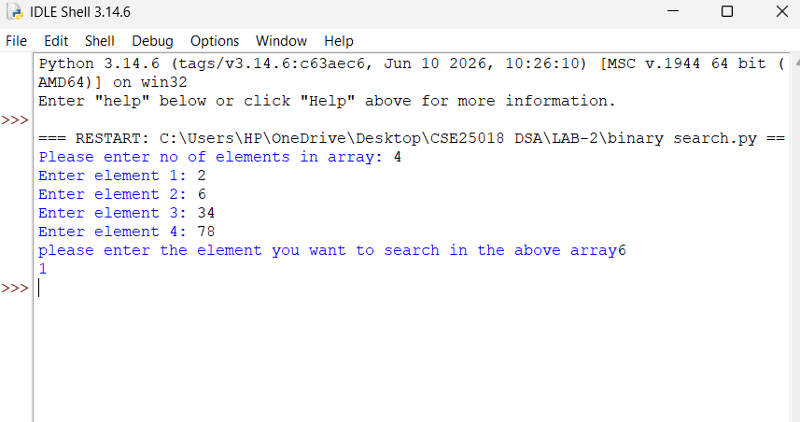

Explanation:-
The program takes the number of elements and the array elements as input from the user. The binary_search function uses two pointers, left and right, that mark the current search boundaries within the list. In each iteration, it calculates the middle index, mid, and compares the element at that position with the target value. If they match, the index is returned. If the middle element is smaller than the target, the search continues in the right half by updating left to mid + 1; if it is larger, the search continues in the left half by updating right to mid - 1. This process repeats until the element is found or left exceeds right, in which case -1 is returned. Binary search requires the input list to be sorted in advance, and it is significantly faster than linear search for large datasets, running in O(log n) time compared to linear search's O(n).

Error Table:-
S.No | Error / Exception | Cause | Solution
1 | Incorrect or missing result | The array entered by the user is not sorted, but binary search assumes a sorted array. | Sort the array (e.g., using arr.sort()) before calling binary_search, or ensure the user enters elements in ascending order.
2 | ValueError | A non-integer value is entered for the number of elements, array elements, or the target. | Enter only valid integer values when prompted, or add input validation using try-except.
3 | Result of search not displayed | The returned value of binary_search(arr, target) is not stored or printed. | Store the function's return value in a variable and print it, e.g., result = binary_search(arr, target); print(result).
4 | Infinite loop | The left and right pointers are updated incorrectly, so the while condition never becomes false. | Ensure left is set to mid + 1 and right is set to mid - 1 exactly as required by the algorithm.

LAB-3
Question 1: Bubble Sort
Question-
Write a Python program to sort a list of elements entered by the user using the Bubble Sort algorithm.
Aim:-
To implement and understand the working of the Bubble Sort algorithm, which repeatedly compares adjacent elements and swaps them if they are in the wrong order, causing larger elements to 'bubble up' to the end of the list with each pass.

Code:-
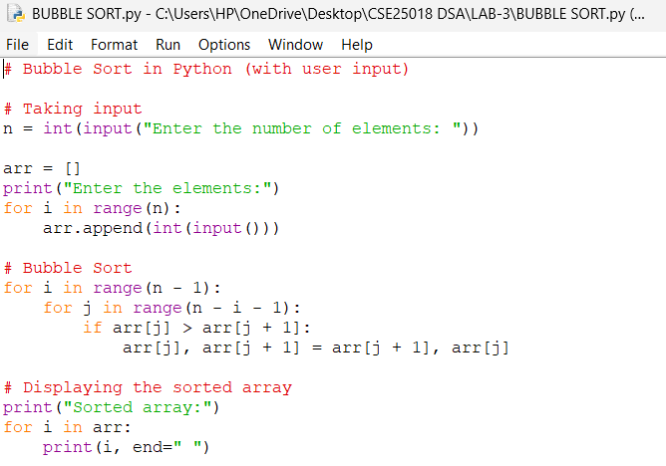

Output:-
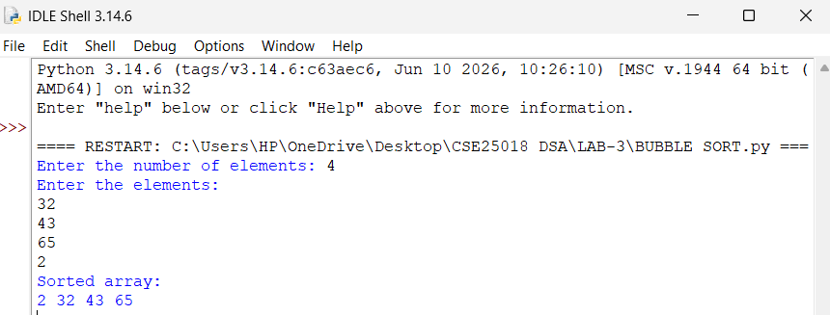

Explanation:-
The program first takes the number of elements and the elements themselves as input from the user and stores them in a list. The sorting logic uses two nested loops: the outer loop runs n - 1 times, representing each pass through the list, and the inner loop compares each pair of adjacent elements, arr[j] and arr[j + 1]. If an element is greater than the one next to it, the two are swapped. After each complete pass of the inner loop, the largest unsorted element is guaranteed to move to its correct position at the end of the array, so the range of the inner loop can safely shrink on each subsequent pass. This process continues until no more swaps are needed and the entire list is sorted in ascending order. Bubble sort has a time complexity of O(n^2) in the average and worst cases, making it simple to understand but inefficient for large datasets.

Error Table:-
S.No | Error / Exception | Cause | Solution
1 | ValueError | User enters a non-integer value when prompted for the number of elements or the array elements. | Enter only valid integer values when prompted, or add input validation using try-except.
2 | Array remains unsorted / partially sorted | The inner loop range is written incorrectly (e.g., missing the '- i' term), so later passes re-compare already-sorted elements or skip needed comparisons. | Ensure the inner loop runs as range(n - i - 1) so each pass correctly narrows down to the unsorted portion of the list.
3 | IndexError: list index out of range | The inner loop condition allows j + 1 to go beyond the last valid index of the array. | Keep the inner loop bound at n - i - 1 (not n) so that arr[j + 1] always refers to a valid index.

Question 2: Insertion Sort
Question-
Write a Python program to sort a list of elements entered by the user using the Insertion Sort algorithm.
Aim:-
To implement and understand the working of the Insertion Sort algorithm, which builds a sorted list one element at a time by picking each element and inserting it into its correct position among the previously sorted elements.
Code:-
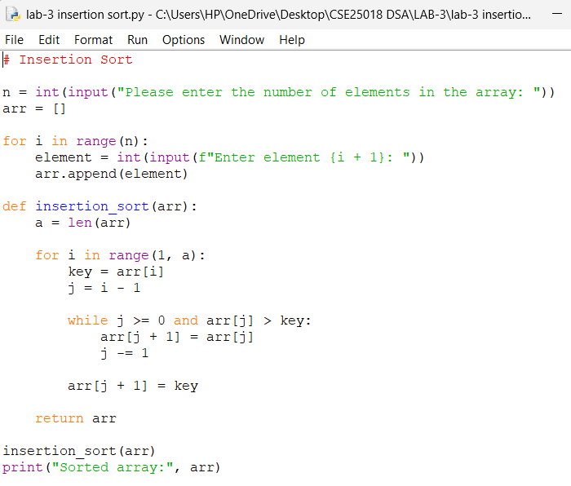

Output:-
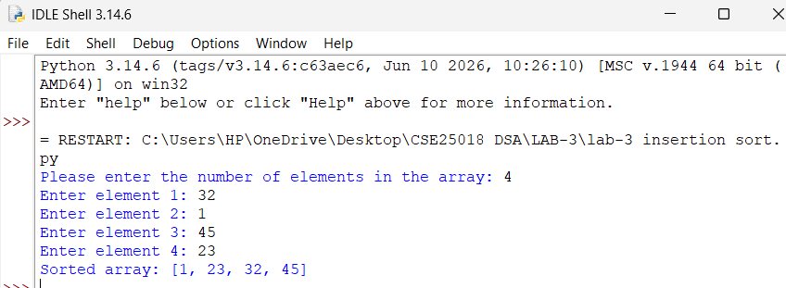

Explanation:-
The program takes the number of elements and the array elements as input from the user. The insertion_sort function starts from the second element (index 1) and treats it as the 'key' to be inserted into the sorted portion of the array that lies to its left. Using a while loop, it shifts each element in the sorted portion that is greater than the key one position to the right, creating space for the key. Once the correct position is found — that is, once j becomes less than 0 or arr[j] is no longer greater than the key — the key is placed at index j + 1. This process repeats for every element from index 1 to the end of the array, gradually growing the sorted portion until the entire list is sorted in ascending order. Insertion sort performs well on small or nearly-sorted lists, with a time complexity of O(n^2) in the worst case but close to O(n) when the input is already almost sorted.

Error Table:-
S.No | Error / Exception | Cause | Solution
1 | ValueError | User enters a non-integer value when prompted for the number of elements or the array elements. | Enter only valid integer values when prompted, or add input validation using try-except.
2 | Array remains unsorted | The while loop condition or the shifting step (arr[j + 1] = arr[j]) is written incorrectly, so elements are not shifted properly. | Ensure the while loop runs while j >= 0 and arr[j] > key, and that arr[j + 1] = key is placed correctly after the loop ends.
3 | IndexError: list index out of range | The while loop condition checks arr[j] before confirming that j >= 0, causing access to a negative or invalid index. | Always check j >= 0 first in the while condition (Python evaluates conditions left to right, so order matters for short-circuiting).

Question 3: Merge Sort
Question-
Write a Python program to sort a list of elements entered by the user using the Merge Sort algorithm.
Aim:-
To implement and understand the working of the Merge Sort algorithm, which uses a divide-and-conquer approach to recursively split the list into halves, sort each half, and then merge the sorted halves back together.
Code:-
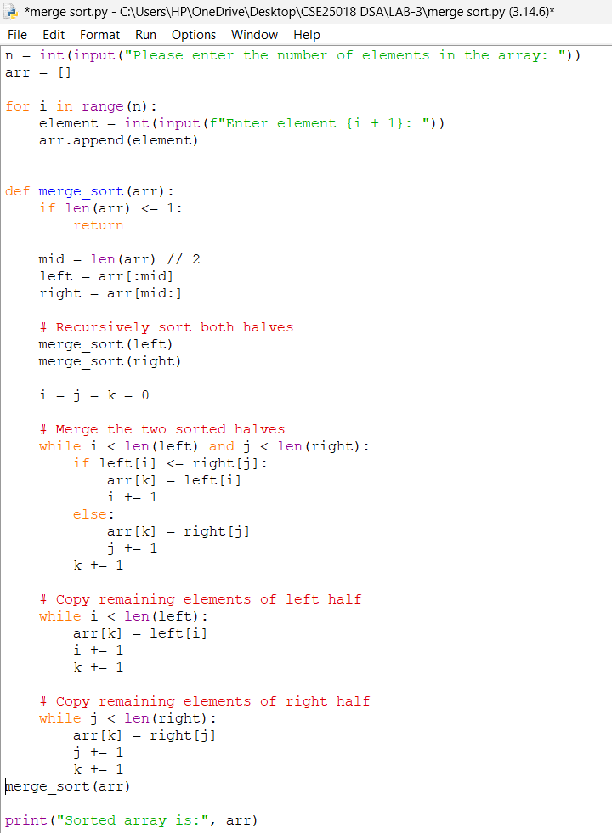
Output:-
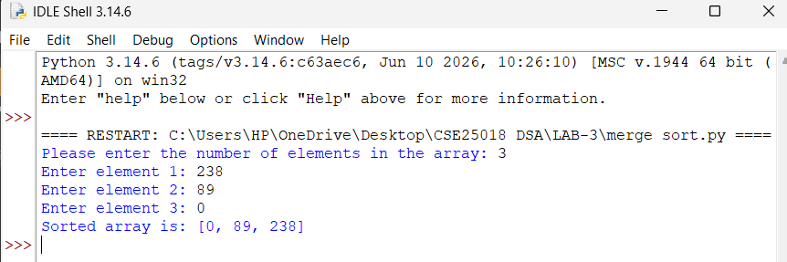

Explanation:-
The program takes the number of elements and the array elements as input from the user. The merge_sort function first checks whether the list has one or zero elements, in which case it is already sorted and the function returns immediately. Otherwise, the list is divided into two halves, left and right, at the midpoint. The function then calls itself recursively on each half, breaking the problem down until every sub-list contains a single element. The merging step then combines two sorted halves into one sorted list by comparing the smallest remaining elements of each half and placing the smaller one into the original array at position k, advancing the corresponding pointer (i or j) each time. Once one half is fully placed, any remaining elements from the other half are copied over directly, since they are already sorted. This divide-and-conquer approach gives merge sort a time complexity of O(n log n) in all cases, making it considerably more efficient than bubble, selection, or insertion sort for large datasets, though it requires additional memory for the temporary left and right sub-lists.

Error Table:-
S.No | Error / Exception | Cause | Solution
1 | ValueError | User enters a non-integer value when prompted for the number of elements or the array elements. | Enter only valid integer values when prompted, or add input validation using try-except.
2 | RecursionError: maximum recursion depth exceeded | The base case (if len(arr) <= 1: return) is missing or incorrect, so the recursive calls never stop. | Ensure the base case is present and correctly checks for lists of length 0 or 1 before dividing further.
3 | Array remains unsorted or partially merged | The merging step's while loops or index variables (i, j, k) are updated incorrectly, so elements are skipped or overwritten. | Carefully update i, j, and k exactly once per comparison, and ensure all three 'while' loops (main merge and the two leftover-copy loops) are included.

Question 4: Selection Sort
Question-
Write a Python program to sort a list of elements entered by the user using the Selection Sort algorithm.
Aim:-
To implement and understand the working of the Selection Sort algorithm, which repeatedly selects the smallest remaining element from the unsorted portion of the list and places it at the beginning of that portion.
Code:-
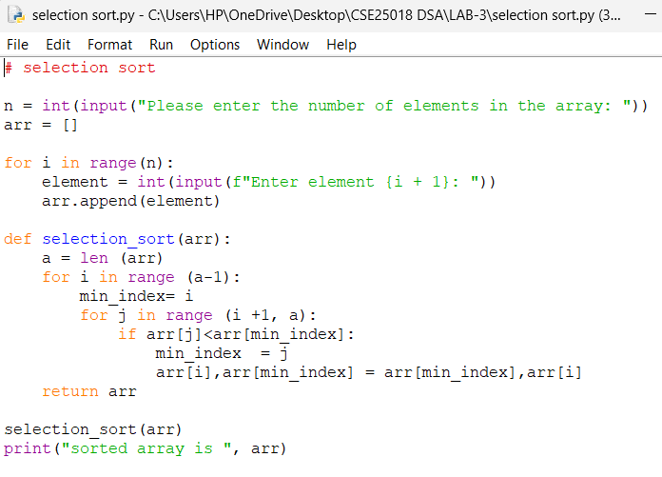
Output: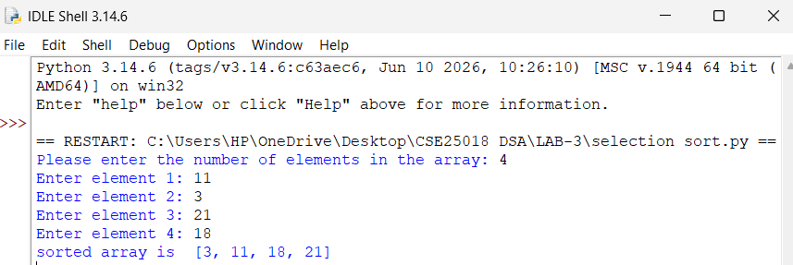
Explanation:-
The program takes the number of elements and the array elements as input from the user. The selection_sort function uses an outer loop that runs from the first index to the second-last index, treating each position i as the start of the current unsorted portion. For each i, an inner loop scans through the remaining elements to find the index of the smallest value, keeping track of it in min_index. Once the smallest element in the unsorted portion has been located, it is swapped with the element at position i, placing it in its correct sorted position. This process repeats for each position, progressively growing the sorted portion at the front of the list until the entire array is sorted in ascending order. Selection sort has a time complexity of O(n^2) in all cases, since it always scans the remaining unsorted elements regardless of how nearly sorted the list already is, but it performs a minimal number of swaps compared to other quadratic sorting algorithms.

Error Table:-
S.No | Error / Exception | Cause | Solution
1 | ValueError | User enters a non-integer value when prompted for the number of elements or the array elements. | Enter only valid integer values when prompted, or add input validation using try-except.
2 | Array remains unsorted or incorrectly sorted | The swap statement is placed inside the inner loop instead of after it, so elements are swapped multiple times per pass instead of once with the final minimum. | Move the swap (arr[i], arr[min_index] = arr[min_index], arr[i]) outside and after the inner for loop, so it executes only once per outer loop iteration.
3 | IndexError: list index out of range | The inner loop range is written incorrectly, causing j or min_index to exceed the valid index range of the array. | Ensure the inner loop runs as range(i + 1, a) so all indices accessed remain within bounds.

Question 5: Quick Sort
Question-
Write a Python program to sort a list of elements entered by the user using the quick Sort algorithm.
Aim:-
To implement and understand the working of the quick sort algorithm and understand how the algorithm divides the array and sort step by step using iterations and loops
Code :-
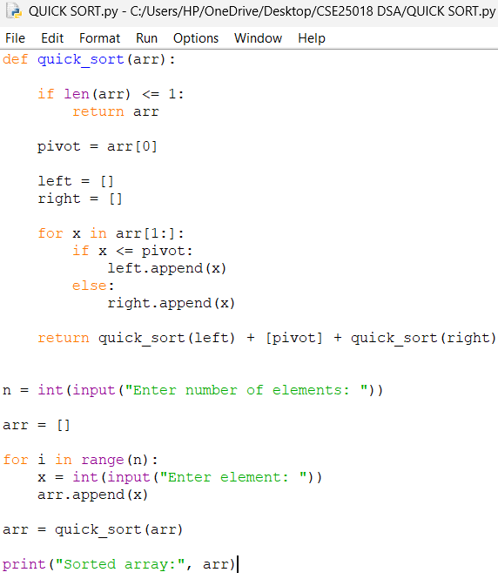
Output:- 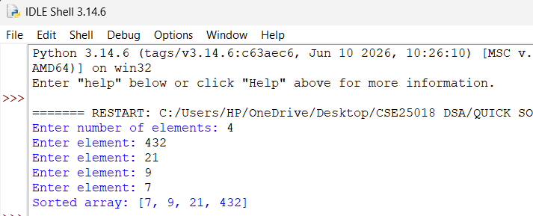

Explanation:-
Quick Sort is a divide-and-conquer sorting algorithm that selects an element as a pivot and divides the array into elements smaller than the pivot and elements greater than the pivot. It then recursively sorts these two parts and combines them with the pivot to produce the sorted array. Its average time complexity is O(n log n), while its worst-case complexity is O(n²).

Lab-4
Question 1:-
Write a Python program to implement a Singly Linked List using a menu-driven approach. The program should:
- Create a singly linked list from an array of elements.
- Insert a node at the beginning.
- Insert a node at the end.
- Insert a node at a specific index.
- Delete a node from the beginning.
- Delete a node from the end.
- Delete a node containing a specific value.
- Count the number of nodes.
- Display the linked list.
- Exit the program.

Aim:-

To implement a menu-driven Python program for a Singly Linked List and perform various operations such as insertion, deletion, counting, and displaying the elements of the linked list.

Code :-

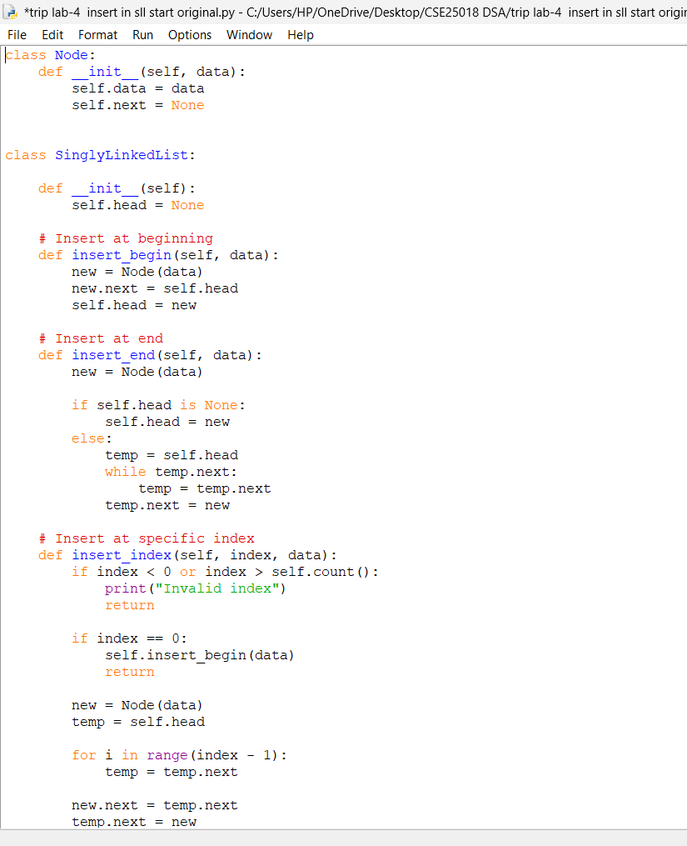

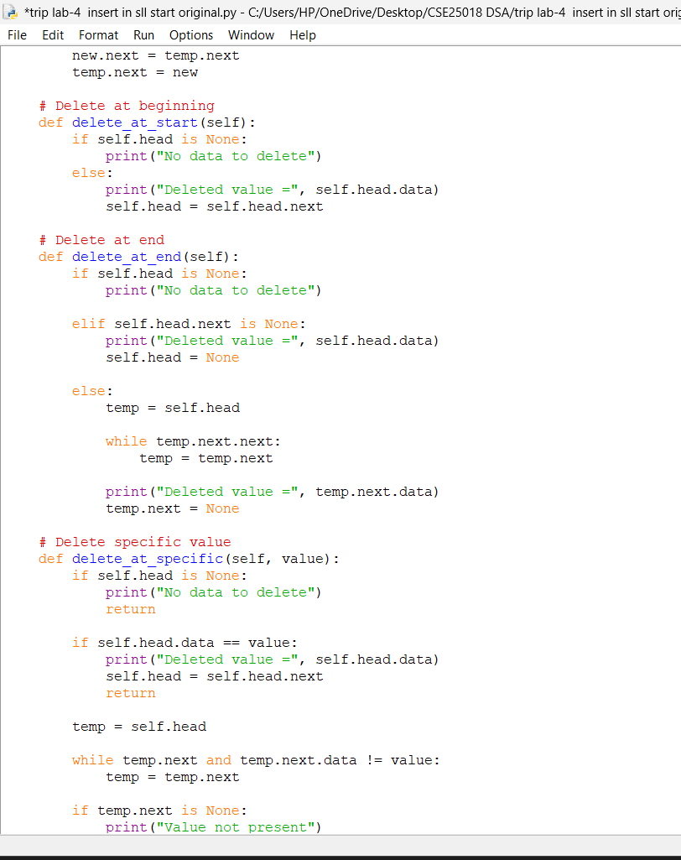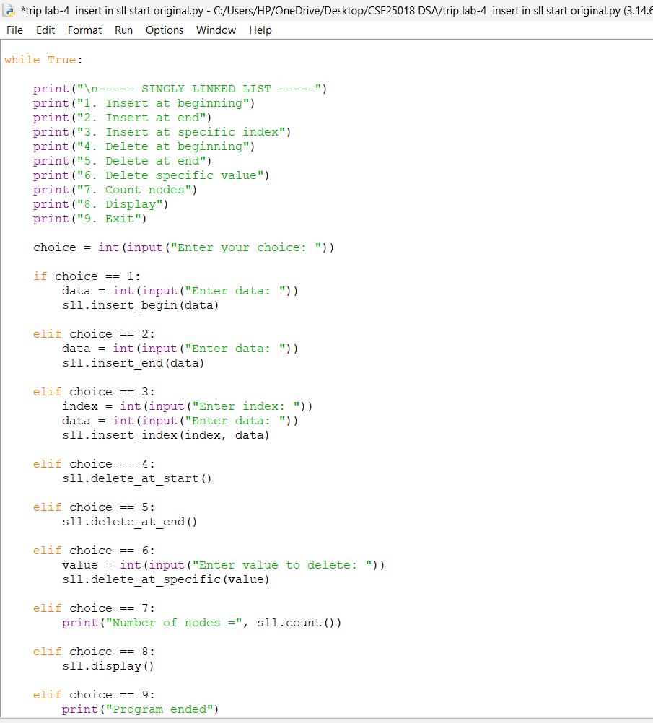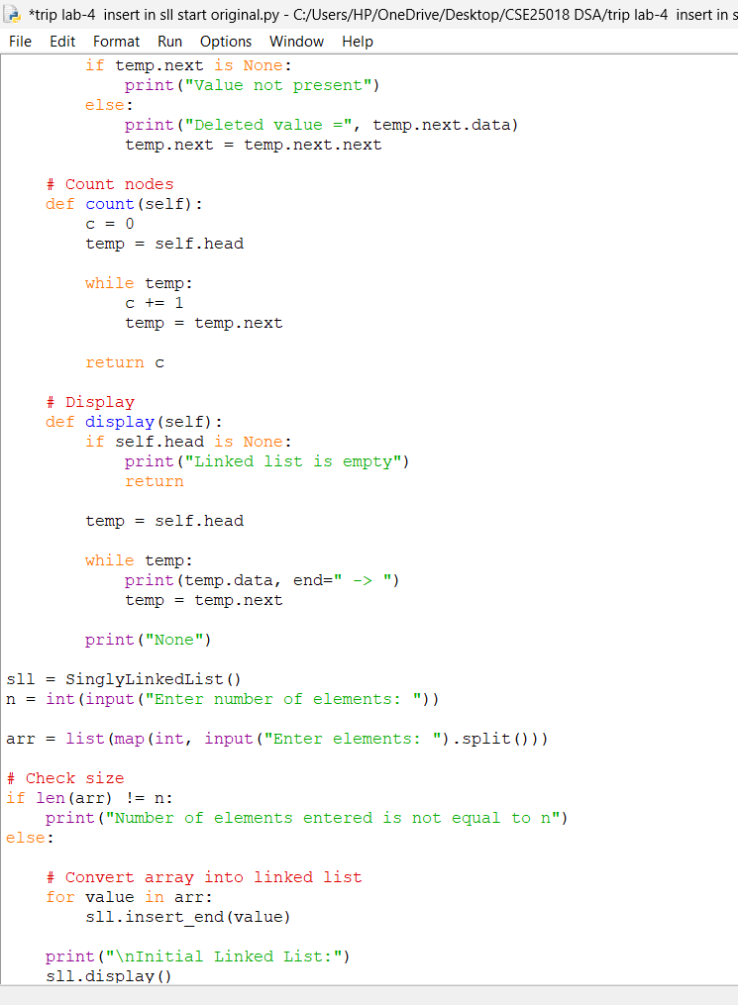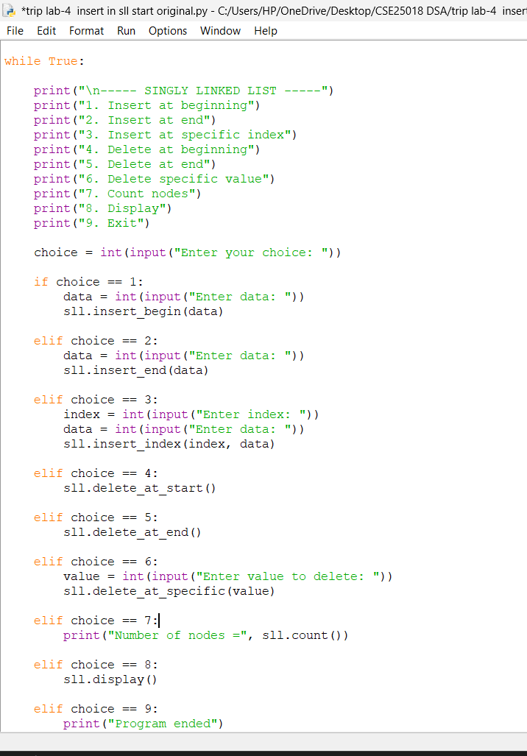

Code Output:-
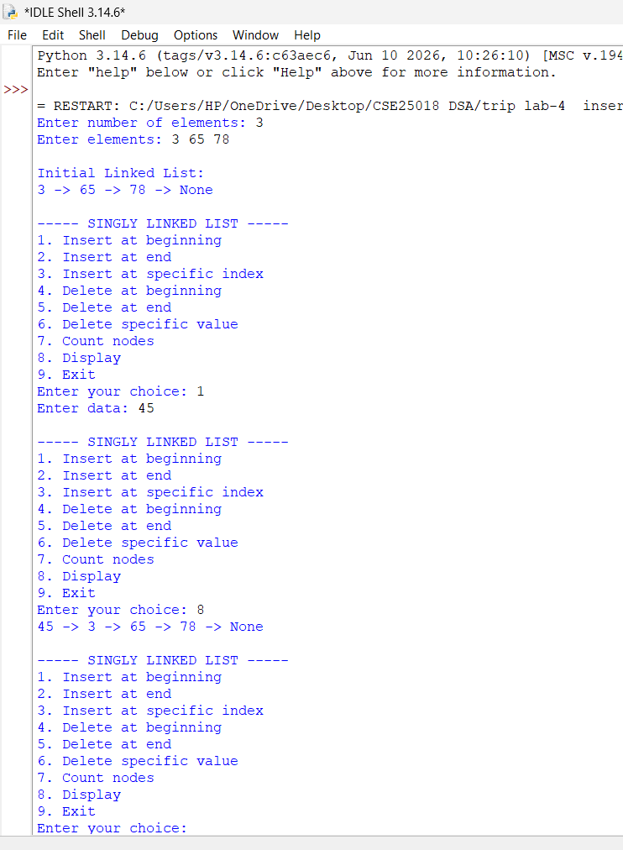

Explanation:-
This program implements a Singly Linked List in Python using a menu-driven approach. It first takes array elements as input and converts them into linked-list nodes. The program provides operations to insert nodes at the beginning, end, or a specific index, and to delete nodes from the beginning, end, or by a specific value. It can also count the number of nodes and display the linked list.

Error Table:-
ERROR | Possible Cause | Solution
List Underflow | delete() or traverse() called when the list is empty (head is None) | Check that head is not None before deleting or traversing; insert a node first
AttributeError: 'NoneType' object has no attribute 'next' | Accessing .next on a node that is already None (e.g., traversing past the last node) | Check that the current node is not None before accessing current.next
Node not found during deletion | The value to be deleted does not exist anywhere in the list | Search the list first and print a "not found" message if the value is absent

Question 4(b):
Write a Python program to implement a Doubly Linked List using a menu-driven approach. The program should:
1.Create a singly linked list from an array of elements.
2.Insert a node at the beginning.
3.Insert a node at the end.
4.Insert a node at a specific index.
5.Delete a node from the beginning.
6.Delete a node from the end.
7.Delete a node containing a specific value.
8.Count the number of nodes.
9.Display the linked list.
10.Exit the program.

Aim

To implement a menu-driven Python program for a Doubly Linked List and perform various operations such as insertion, deletion, counting, and displaying the elements of the linked list.

Code :

Code Output:-
Explanation:-
In Doubly Linked List code, a Node has data, prev and next pointers. head pointer holds the first node of list. next pointer of a node is used to point to next node in list. prev pointer of a node is used to point to previous node in list. During insertion and deletion both the pointers are updated to form links between nodes. A while loop is used to traverse through list of nodes. In DLL code, we can insert, delete, search and display elements in list. These operations are performed when we require to move in list in forward as well as backward direction.
Error Table:-
ERROR | POSSIBLE SOLUTION | SOLUTION
List Underflow | delete() or traverse() called when the list is empty (head is None) | Check that head is not None before deleting or traversing
Dangling tail pointer | tail is not updated after the last node is deleted | Update tail to point to the previous node whenever the last node is removed
Question-3-
Write a Python program to implement a Circularly Linked List using a menu-driven approach. The program should:
1.Create a circular linked list from an array of elements.
2.Insert a node at the beginning.
3.Insert a node at the end.
4.Insert a node at a specific index.
5.Delete a node from the beginning.
6.Delete a node from the end.
7.Delete a node containing a specific value.
8.Count the number of nodes.
9.Display the linked list.
10.Exit the program.

Aim:-

To implement a menu-driven Python program for a Circular Linked List and perform various operations such as insertion, deletion, counting, and displaying the elements of the linked list.

Code:-

Code output:-

Explanation:-
In Circular Linked List code, a Node class is used to create each node containing data and a next pointer. The head pointer stores the first node of the list. During insertion, the new node is connected to another node using the next pointer. The last node always points back to the head, making the list circular. A while loop is commonly used to traverse the list until we reach the head again. CLL code is useful for insertion, deletion, searching, and displaying elements. It is mainly used when data needs to be processed repeatedly in a circular manner.

Error Table:-
ERROR | POSSIBLE SOLUTION | SOLUTION
Infinite loop | Loop condition checks while node is not None but in a circular list the last node points back to head, never to None | Use while node is not head checked after the first step or a do-while style loop
Last node not linked back to head | Forgetting to set the new last node's next to head after insertion | Always update tail.next = head immediately after every insertion or deletion
Single-node deletion error | Deleting the only node in the list without resetting head to None | Explicitly check if head.next == head (only one node) and set head = None in that case

LAB- 5

1. Program to Implement Stack Using Linked List
Aim:-
To write a Python program to implement the operations of a Stack (Push, Pop, Peek, and Display) using a singly linked list, and to verify its working through a menu-driven interface.
Code:-

Code Output:-

Explanation:-
The program implements a Stack using a linked list instead of a fixed-size array, so it can grow dynamically. The Node class defines a single unit of the list, storing a data value and a reference (next) to the following node. The Stack class maintains only one pointer, top, which always refers to the most recently inserted node.The push() method creates a new node, links it to the current top, and then updates top to point to this new node — this places every new element at the front of the list, which corresponds to the top of the stack, giving O(1) insertion. The pop() method checks whether top is None (an empty stack, called Stack Underflow); if not empty, it prints the data of the current top node and then moves top to the next node, effectively removing the old top.The peek() method simply reports the data stored at top without removing it, while display() traverses the linked list from top to the last node, printing each element, thereby showing the entire stack content in Last-In-First-Out (LIFO) order. Finally, the menu-driven loop repeatedly asks the user to choose an operation and calls the corresponding method until the user selects the Exit option (choice 5), at which point the loop breaks and the program terminates.

Error Table:-
Error | Possible Cause | Solution
Stack Underflow | pop() or peek() is called when the stack is empty (top is None) | Check if the stack is empty before performing pop/peek; push an element first
ValueError: invalid literal for int() | Non-numeric text entered at the choice or element prompt | Enter only numeric values, or wrap input() in a try–except block
"Invalid choice" printed repeatedly | A menu option outside the range 1–5 is entered | Enter a valid option between 1 and 5
Program does not terminate | Option 5 (Exit) is never selected | Select choice 5 to break out of the while loop

2. program to implement stacks using array
Aim:-
To write a Python program to implement the operations of a Stack (Push, Pop, Peek, and Display) using an array , and to verify its working through a menu-driven interface.
Code:-
Code Output:-

Explanation:-
The stack using an array is implemented using a Python list, where the elements are stored in the order they are inserted. The variable top keeps track of the position of the last element in the stack and initially it is set to -1, which indicates that the stack is empty. During the push operation, an element is added using append() and top is increased by one. During the pop operation, the top element is removed using pop() and top is decreased by one. The peek operation displays the element present at the top position without removing it. Since a stack follows LIFO (Last In, First Out), the element inserted last is always removed first

ERROR TABLE:
ERROR | SOLUTION
Stack Using Array – Error | Meaning | Condition
Stack Overflow | Trying to insert an element when the stack is full | top == MAX - 1
Stack Underflow | Trying to delete an element when the stack is empty | top == -1
Invalid Peek | Trying to view the top element when the stack is empty | top == -1

Lab-6

1(a). Program to Implement Queue Using Linked List

Aim:-
To write a Python program to implement the operations of a Queue (Enqueue, Dequeue, Peek, and Display) using a singly linked list, and to verify its working through a menu-driven interface
Code:-

Code output:-
:

Explanation:-
This program implements a Queue using a linked list, allowing First-In-First-Out (FIFO) behaviour with dynamic size. The QueueEx class keeps two pointers: front, which refers to the node that will be removed next, and rear, which refers to the most recently added node — this lets both insertion and removal be performed in O(1) time without traversing the list.The enqueue() method creates a new node and, if the queue is currently empty (rear is None), sets both front and rear to this new node; otherwise, it links the new node after the current rear and then updates rear to point to it, so new elements always join at the back of the queue. The dequeue() method first checks whether front is None (an empty queue, called Queue Underflow); if not, it reads the data at front, advances front to the next node, and — if the queue has now become empty — also resets rear to None so both pointers stay consistent.The peek() method reports the data at front without removing it, and display() walks the list from front to rear, printing every element in the order they would be dequeued. As with the stack program, a menu-driven while loop repeatedly reads the user's choice and calls the matching method, continuing until choice 5 (Exit) is selected, which breaks the loop and ends the program.

Error Table:-
Error | Possible Cause | Solution
Queue Underflow | dequeue() or peek() is called when the queue is empty (front is None) | Check if the queue is empty before dequeuing/peeking; enqueue an element first
ValueError: invalid literal for int() | Non-numeric text entered at the choice or element prompt | Enter only numeric values, or wrap input() in a try–except block
Invalid choice printed repeatedly | A menu option outside the range 1–5 is entered | Enter a valid option between 1 and 5
rear left pointing to a stale node | front becomes None after dequeue but rear is not reset | Ensure dequeue() sets rear = None whenever the last element is removed (already handled in this code)

6(b). program to implement queue using array

Aim:-
To write a Python program to implement the operations of a Queue (Enqueue, Dequeue, Peek, and Display) using an array , and to verify its working through a menu-driven interface.
Code:-

Code output:-

Explanation:
The queue using an array is implemented using a Python list along with two variables called front and rear. The front variable indicates the position from where elements are removed, while rear indicates the position where new elements are inserted. Initially, front is set to 0 and rear is set to -1, indicating that the queue is empty. During the enqueue operation, an element is added to the array and rear is increased. During the dequeue operation, the element at the front position is removed logically by moving front to the next position. The queue follows FIFO so the element inserted first is removed first.
ERROR TABLE:
Error | solution
Queue Overflow | rear == MAX - 1
Queue Underflow | front > rear
Invalid Dequeue | front > rear

